|  |  |  |  |
| --- | --- | --- | --- |
|  | Bansilal Ramnath Agarwal Charitable Trust's  Vishwakarma Institute of Information Technology  **Department of**  **Artificial Intelligence and Data Science** | | |
| Name: Siddhesh Dilip Khairnar | | | |
| Class: SY | Division: B | | Roll No: 272028 |
| Semester: 4th | | Academic Year:2022-2023 | |
| Subject Name & Code: Fundamentals of computer network (22203) | | | |
| **Title of Assignment: Wired LAN setup by using Cisco Packet Tracer.** | | | |
| Date of Performance: 20/01/23 | | Date of Submission: 26/01/23 | |

Theory/ Writeup:

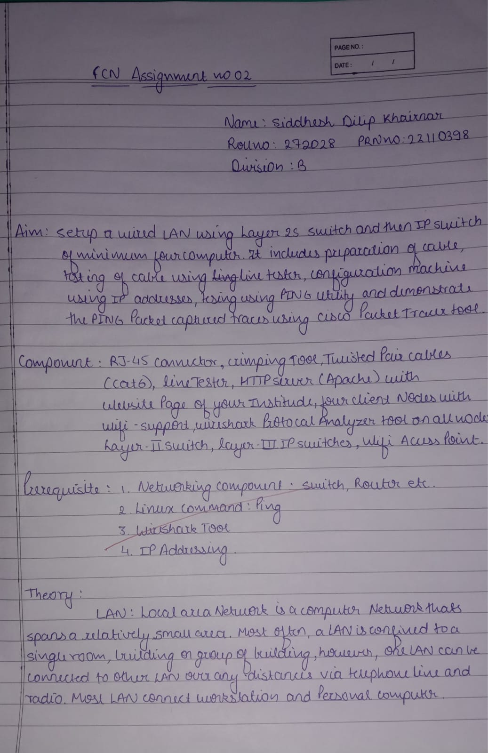

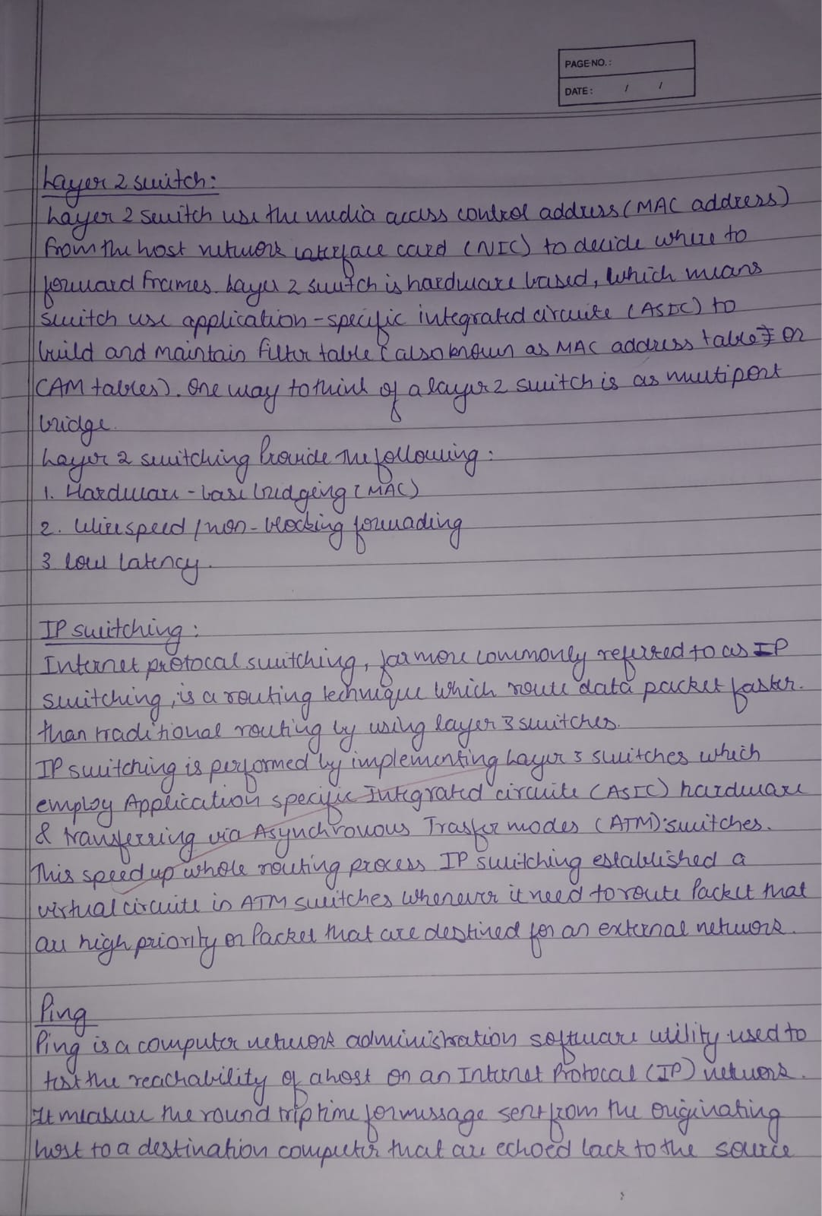

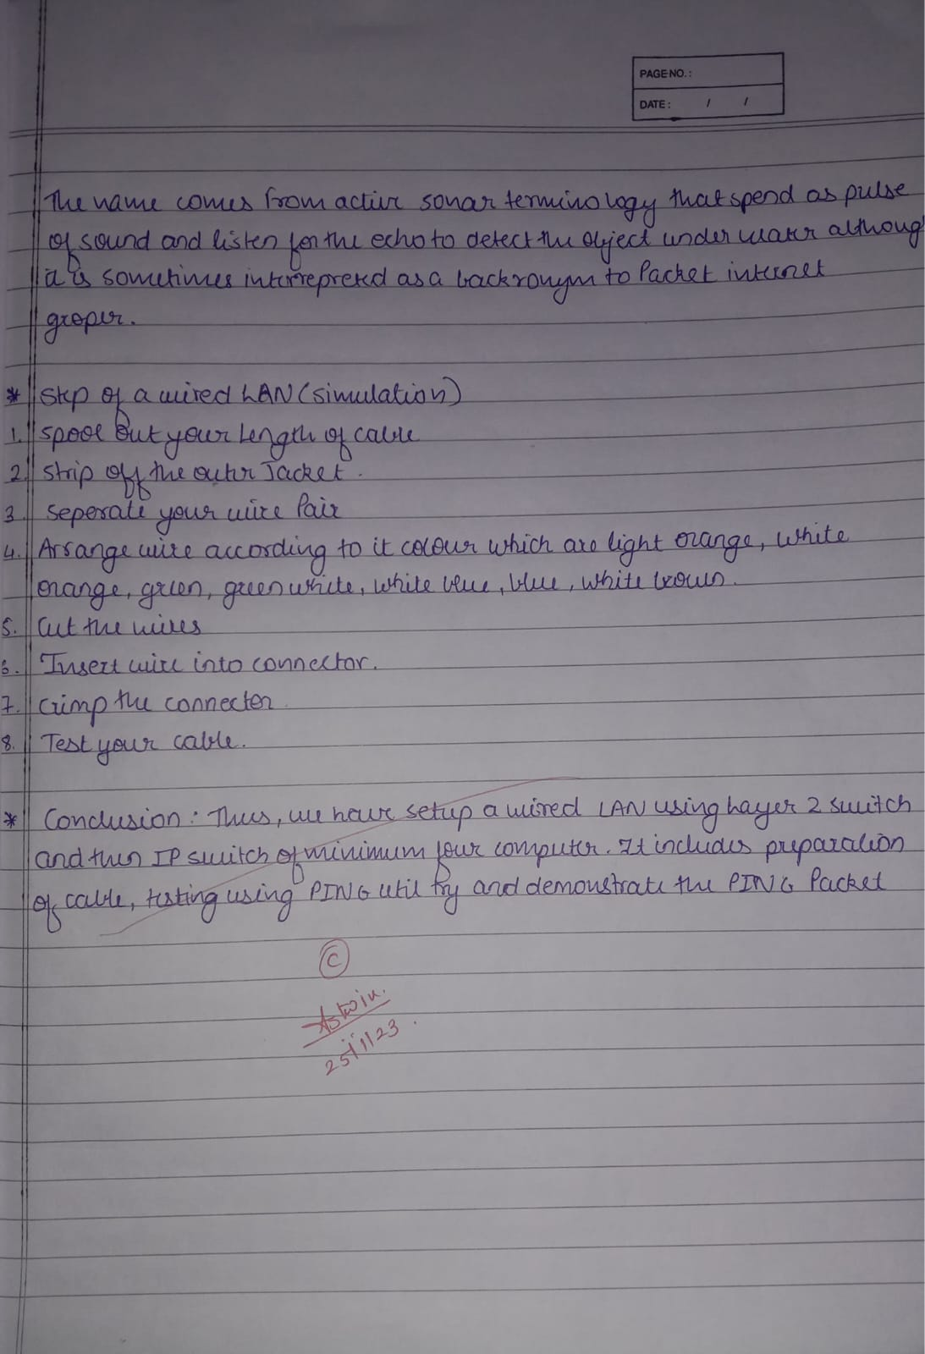

Snapshot of implementation:

